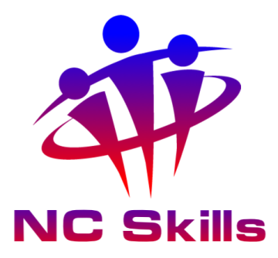
To whom it may concern,

(Candidate Name) is completing the ProQual Level 4 Diploma in Spectator Safety Management with NC Skills and has outlined your name as their assigned witness, someone who can witness their work and can support their competency claims. Throughout the qualification, you will be required to provide statements of direct observations that have taken place. I am therefore contacting you to authenticate your eligibility and identify credentials.

NC Skills are required to complete this quality check in compliance with regulations outlined by awarding body ProQual. Unfortunately, without doing so, NC Skills are unable to accept any work produced by the student until expert witness credentials have been approved.
Could you please complete the table below and provide us with copies of the requested documents including photographic ID, email from a business address showing your job title in the email signature.

Surname
Forename
Telephone number:
(ProQual may contact you by telephone to verify your details)
Professional Qualifications:
Please send copies of any certificates by email when returning this form
Professional memberships (if applicable):
Please send copies of any certificates by email when returning this form
Signed:
I declare the information provided ...
Date:

Form to be returned, with supporting documents including photo ID (copy of passport, driving license) , Current CV and any membership/professional certificates to admin@ncskills.com
By completing and returning you are agreeing NC Skills can share your information with ProQual for the above outlined purpose.
We thank you for your co-operation.

NC Skills Team

